**TechRidge: A platform for developers to develop their technical potential and inter-personal skills**

**Aparna R, Abhishek S, K Sidhartha Nambiar, Keshava Pranath K, Lakshya Sharma**

**Abstract**

TecRidge is a platform that enables developers to learn about the projects going on in their surroundings. Students gain practical experience only by indulging themselves into different projects and only through this they get introduced to new concepts of technologies whose practical knowledge can help them in their career. Currently there are platforms which rank the coders based on their competitve coding ability, which is a really good metric but developers develop things which can be helpfull to the society and there are no platforms for ranking a person based on these factors. Even if such platform exists it is common opinion that people get bored of the system after a certain point of time. Coding experience must be enjoyable making it more fun to create something. New ideas pop up in our mind when we know about others’ ideas and think of making it better. Team work is something which is important to a project as it will decide at what rate the project can get finished and how efficiently the work was done. Also, the developers can add their own ideas into the platform where they can come across the fellow developers, so that they can team up and hence make a better quality product of their idea. Also the developers can find for the suitable guide to guide them in their way to build the product. Today technology has grown far way long, that all fields of developing can combine to produce great products.

**Introduction**

Students gain practical experience only by indulging themselves into different projects and only through this they get introduced to new concepts of technologies whose practical knowledge can help them in their career. But the students with skills may not be having ideas and people with ideas may not be having skills to work upon those ideas.

New ideas pop up in our mind when we know about others’ ideas and think of making it better. Team work is something which is important to a project as it will decide at what rate the project can get finished and how efficiently the work was done.

Currently there are platforms which rank the coders based on their competitve coding ability, which is a really good metric but developers develop things which can be helpfull to the society and there are no platforms for ranking a person based on these factors. Even if such platform exists it is common opinion that people get bored of the system after a certain point of time. Coding experience must be enjoyable making it more fun to create something.

Many students in a college are unaware of the project works going on in their departments and the research activities undergoing in the college. The main reason for this can be communication gap between the students or between students and professors.

So, we here as developers try to solve this problem by creating a platform where ongoing projects of the departments will be listed. Any students interested to work on the listed projects can contact the guide or the head of the project.

We, as developers, when worked on teams can bring up great products. But in the current existing platforms developers are isolated and are unaware of essentiality and power of the team work. The developers build very useful things for the society, may be targetted groups or universal. But the majority of developers are hidden and no platform is present for their recognition.

Also majority of the developers today are cut half their way because of lack of motivation in the area of their interest. Today technology has grown far way long, that all fields of developing can combine to produce great products.

Hence, here we put forward a platform where we see group of developers working on their area of interest competing with each other, just to provide the society a great product and also themselves a note of recognition.

Objective of the Project:

* To provide an informative interface:

Here we provide an interface where students can know about the work happening around them in the college.Students in a college sometimes doesn't have any idea about the projects undergoing in their department or in other departments where they can work on the areas of their interest.

* To provide the opportunity to upload their own projects/ideas:

Each student working on a project of their own or under some professor will list it in this interface with their interest. All the students of that college will be able to see the project listed here.

* To provide the opportunity to contact previous project heads to continue or improve the same project:

Any student interested in working on a particular project will be able to contact the guide and head of the project team, provided in the description.

* To provide the students a platform where they can get an idea on how to proceed ahead in project development:

Also the projects completed earlier by some students can be used for extended ideas by the permission of the project lead listed in the project. This will help the students of next generation to know the patterns of the projects made by the students earlier.

* Providing a platform for aspiring developers of all forms to include themselves in groups:

Students interested in developing are usually isolated, unlike competitive coding. While developing is complete team work in any of the industry. We aim at providing a platform for aspiring developers of all forms to include themselves in groups. This will allow them to have experience with variety of developers throughout the engineering life, which will help them in industry.

* To provide a healthy environment for developers to enhance their developer skills:

Quality of developers can be increased when we have a group of developers discussing and challenging each other with their developing skills. This also provides a healthy environment for developers to enhance their developer skills and present their best to the society.

Model Used for building

Spiral model:

An iterative approach where multiple passes are made through each phase. During each iteration the system is explored at greater depth and more detail is added.   Appropriate for exploratory projects that are working in an unfamiliar domain or with unproven technical approaches.  The iterative natures allows for knowledge gained during early passes to inform subsequent passes.  Requires low up-front commitment.

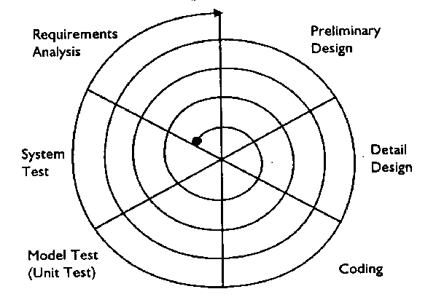

**ReactJS** is a popular open source front-end JavaScript library developed by Facebook, popular for the simplicity and ease of use with efficient working. In ReactJS, all the components govern their own state and manipulate UI according the state changes, making sure that only required part of the UI changes according the requirement.

**Redux** is a predictable state container for javascript apps. It helps to write application that behave consistently, run in different environments and are easy to test. The object is like a “model” except that there are no setters. This is so that different parts of the code can’t change the state arbitrarily, causing hard-to-reproduce bugs. To change something in the state, you need to dispatch an action. An action is a plain JavaScript object that describes what happened. Enforcing that every change is described as an action lets us have a clear understanding of what’s going on in the app. If something changed, we know why it changed. Actions are like breadcrumbs of what has happened. Finally, to tie state and actions together, we write a function called a reducer.

Genetic algorithms are a family of meta-heuristic search algorithms that are derived from the nature’s evolutionary techniques. Adjusting and optimizing of parameters is an important problem in practical applications. Because of the global random search capabilities of genetic algorithms, search of optima in a multi dimension search space can be found by randomly adjusting Pc and Pm. Experiments show that the method is reliable and effective. Under normal circumstances, any result has two components, the parameters and their respective weights. The genetic algorithm helps us to approximately find the optimal weight of each parameter which gives out the desired result with least error.

Different with the traditional search algorithm, genetic algorithm is from a set of randomly generated solutions (called the initial solution) to begin the searching process. Population of each individual is a solution of the problem, known as chromosome. Chromosome is a string of symbols, such as a binary string. Iteration in the follow-up of these chromosomes continues to evolve as genetic, using fitness of each generation to measure the quality of the chromosome, to generate the next generation of chromosomes, called offspring. Generations of chromosomes from the previous generation are formatted by crossover or mutation computing. Choose the size according to the fitness part of future generations, out of some future generations, so as to maintain the population size is constant. Chromosome with high fitness is to be selected by high probability. In this way, after several generations, the algorithm converges to the best chromosome; it is likely the optimal solution or sub-optimal solution of the problem.

Distinguished from another kind of genetic algorithm is an improved genetic algorithm. In the standard genetic algorithm a new generation of hybrid populations is formatted after hybridized to the N pairs of mother. And outstanding choice of genetic algorithm is an individual, and the last individual to adapt to get the original value of the largest populations of the individual, such amendments to ensure the satisfaction of the population to adapt to sequence the monotonous reduction of value.

**Risk identification and management**

|  |  |  |  |
| --- | --- | --- | --- |
| **Risk** | **Probability** | **Impact** | **Exposure** |
| Incorrect Software  Functionality | Med | Med | Med |
| Instability of a network | High | High | High |
| Network latency | High | High | High |
| Complexity of  application | Med | High | High |
| Change in project  requirements | High | High | High |
| Technical Risk | Low | Low | Low |

|  |  |
| --- | --- |
| Risk | Mitigation Plan |
| Incorrect Software Functionality | * Organization analysis; Server analysis * User surveys * Prototyping |
| Instability of a network | * Creating a backup network that handles load when main server fails. |
| Network latency | * Using Bit-Torrent protocol for shortest routing approach. |
| Complexity of application | * Deploy persons with prior experience with domain |
| Change in project requirements | * Develop high scalable solution to reduce changes in code whenever there are additional requirements * Conduct a mid-stage review |
| Technical Risk | * Train Resources * Review Prototype with customers * Develop pair programming practices |

**Functional requirements**

Developers can give their skill set, which they are good at, so that any person can see the profile of the developer before taking them into the team in a project. Also guide can see the skill set of student and vice-versa before approaching.

Developer can search through the projects on the platform so that he/she can join any project on their point of interest. Also they can use this functionality to see the projects done in past to modify and upgrade it.

Also we are using **genetic algorithm** to grade the projects uploaded by the developers. This takes the input from the description given by the developer while uploading the project. The data given will be stored in Firebase. It is extracted and used for evaluation in GA and the result is stored back to the Firebase.

**Design architecture**

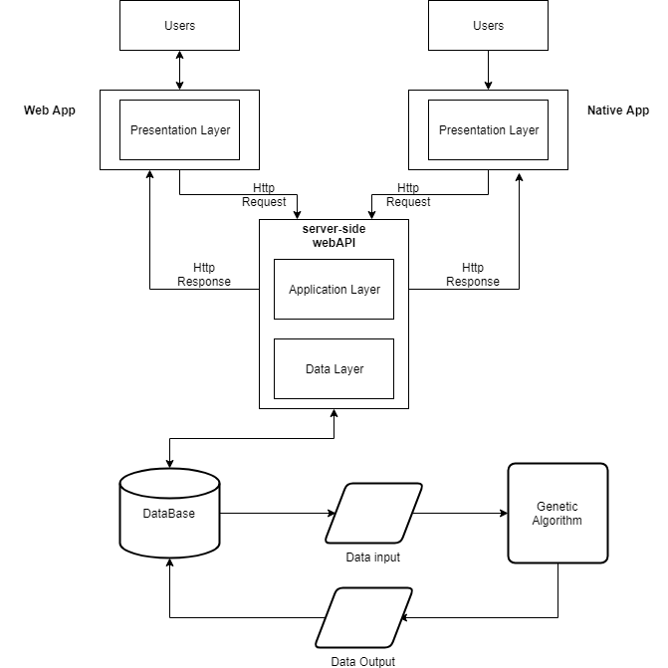

**Algorithm explaination**

Genetic algorithms are a family of meta heuristic, search space algorithms that mimic nature's concepts of survival of the fittest, reproduction and mutation. A genetic algorithm has many parameters that distinguishes it from the other genetic algorithms; some of them are : probability of crossover, probability of mutations, crossover operator, mutation operator, termination conditions, population size, etc. The genetic algorithm we used has a probability of crossover 0.5, probability of mutation 0.01, arithmetic crossover operator with averager a = 0.4, random mutation operator and population size of 2500. The goal is to linearly combine separate, but interdependent parameters, so basically, optimize the set of weights they'll have to calculate an ELO of each project, which will help us to rank them in a just order. As of now this algorithm has 6 parameters to optimize, and room for many more. The algorithm finds optimal points in a multi-dimensional space (7 in our case) to get interesting or ‘hot’ zones, then, successive running of the algorithm accounts for the possible changes in the hot zones, thus making it a less maintenance needing AI algorithm. The individuals in each generation, tend to converge near these hot zones, so as to provide consistent and accurate results every time the algorithm runs.

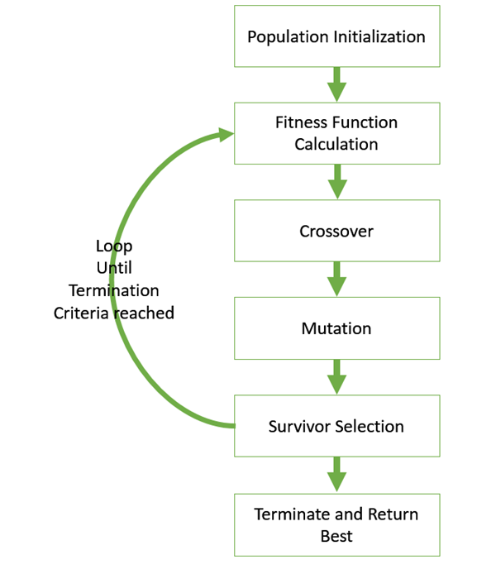

**Testing**

The design we build is modular and we can have unit testing for each modules. Each working UI can be tested individually. Also the GA we implemented can be tested individually. Hence we go with the unit testing and the following test cases are discussed below.

**Initialization**

|  |  |  |  |
| --- | --- | --- | --- |
| **Sl. No.** | **Test Case** | **Expected Result** | **Test Result** |
| **1** | **Web page loading up** | **The web page loads up and asks user to enter login credentials** | **Successful** |

**Authentication**

|  |  |  |  |
| --- | --- | --- | --- |
| **Sl. No.** | **Test Case** | **Expected Result** | **Test Result** |
| **1** | **User profile retrieval** | **The login credentials are verified and the user profile is displayed** | **Successful** |

**Dashboard**

|  |  |  |  |
| --- | --- | --- | --- |
| **Sl. No.** | **Test Case** | **Expected Result** | **Test Result** |
| **1** | **Access to many features of the web site** | **Dashboard is displayed once user is logged in and many features are given to user** | **Successful** |

**Viewing guides,developers profile and project details**

|  |  |  |  |
| --- | --- | --- | --- |
| **Sl. No.** | **Test Case** | **Expected Result** | **Test Result** |
| **1** | **User views guides ,other developers and projects to see to know about them.** | **User gets to know the guide,developer and projects and sends a request** | **Successful** |

**REFERENCES**

1. Elaine Rich, Kevin Knight, Shivashankar B Nair: Artificial Intelligence, 3rd edition, Tata McGraw Hill, 2011 (Genetic Algorithms)
2. Web Application Design and Implementation: Apache 2, PHP5, MySQL, JavaScript, and Linux/UNIX Steven A. Gabarro, December 2006, ©2007, Wiley-IEEE Computer Society Press.(JavaScript)
3. Nate Murray, Felipe Coury, Ari Lerner and Carlos Taborda, “ng-book, The Complete Book on Angular 4” September 2016 3. KrasimirTsonev, “Node.js by Example Paperback”, May 2015. (Nodejs)
4. Tutorial Point - Simply Easy Learnig for Genetic Algorithm (<https://www.tutorialspoint.com/genetic_algorithms/>)
5. Firebase docs- (https://firebase.google.com/docs/web/setup)
6. React-Native(<https://facebook.github.io/react-native/>)
7. Reactjs-( https://reactjs.org/)
8. Redux-( <https://redux.js.org/>)